

Name of Course Instructor**:** Mr. Rabin Thapa

Course Code: CC304 Course Name: Business Case Project

Program Name: B.Sc. (Hons) Computing              Semester: 8th   Batch: 2017

Assignment No. 1 Assignment Type (Individual/Group): Group

Assignment Title: System Requirement Specification

Max. Marks:               Date of Allotment:      Date of Submission:

**Declaration**

I/We hereby declare that the assignment work submitted is original and completed by me/us and as per my/our knowledge and practices.

(Write the individual/group members details below):

**Name of the Student ID number Contact Number Email Id**

Saman Maharjan 1001746975 9803042890 sama171133@iimscollege.edu.np

Sanjiv Maharjan 1001746941 9860265125 sanj171141@ iimscollege.edu.np

Ragim Maskey 1001746939 9808818048 ragi171125@ iimscollege.edu.np

Sohel Maharjan 1001746981 9813043809 sohe171181@ iimscollege.edu.np

Evaluation: ________________________ obtained out of __________________________________

Evaluator’s Comment: __________________________________________________________________________________________________________________________________________________________________________

-------------------------------------------

Evaluator’s Signature & Date

Table of Contents

1. Business Overview 1

1.1 Purpose 1

1.2 Project Stakeholders 1

1.3 Project cost and timeline 2

2 System Context 3

2.1 Background 3

2.2 Interfaces 5

3.0 System Components 5

3.1 Departments 5

3.2 Portals 6

4.0 System Actors 6

5.0 Use Case Definitions and Modeling Diagrams 7

5.1 Use Case 7

5.2 Sequence Diagram 9

5.3 Class Diagram 14

5.4 Activity Diagram 15

5.5 ER diagram 16

6.0 Functional Requirements 16

6.1 Creation of a User 16

6.2 Major Functions 17

6.3 Supporting the system 17

6.4 Enhancing the system 17

7.0 Non-Functional Requirements 17

7.1 Design Standards 17

7.2 Application Interface 18

8 Future Direction 18

9. Conclusion 19

# 1. Business Overview

Trip planner(TP) is a web platform to help users i.e. travelers to schedule their trips to enjoy their time as per their budget. The traditional system of the packages and various other alternatives may not always be suitable for the consumers and they might also want to customize their package and change their plans. So, our system is designed to interact with the user in such a way that he/she will be fascinated by the user interface. Not only the user interface but also the features that are built in the system are based on the needs of the traveler. Where the traveler can not only view the package and activities but also easily edit their activities and the agencies are obliged to supervise the package. Therefore, our system helps users to gain beautiful experience even with constraints of time and money.

## 1.1 Purpose

The purpose of the project is to build a website for the proper satisfaction of the user; i.e. traveler to decrease their difficulty in searching for the proper way to travel. The improvement of the schedule by preparing an automated schedule this system/website will be appropriate for changing plans as on the way, destination based on their time and budget this helps users who want to travel alone and spend their valuable time and money in a quality way and in a beautiful place.

* To provide better services to the travelers
* To improve on the scheduling problem for the traveler
* And most importantly reducing the time, scope and cost of the traveler
* To provide more time in other priority areas such as scheduling.

## 1.2 Project Stakeholders

A stakeholder is either a natural person or a legal person who is interested in financial results and other outcomes. The project stakeholders are usually those who actively participate in a [project](https://www.inloox.com/project-management-glossary/project/) or are influenced by the [project process](https://www.inloox.com/project-management-glossary/project-process/) and can determine the course of the project as well as the project results. They are typically the members of a project team, project managers, executives, project sponsors, customers, and users. It's a good idea to practice good stakeholder management and constantly communicate with them in order to collaborate on the project. Project stakeholders are the company that is responsible to manage tickets and booking. Furthermore, all the companies and people are responsible to make this project successful.

|  |
| --- |
| **Project Name**: Trip planner |
| **Project Charter Author**: |
| **Project Requestor**: |
| **Project Start Date**: 3rd November, 2019 |
| **Project End Date**: 10th December, 2019 |

|  |  |
| --- | --- |
| **Project Description** | The project will include the following activities:  This portal is associated with the field of travels and tours  This portal is to plan the trip that personnel is eager for  The user may find the portal more reliable to be used |
| **Project Purpose** | The main purpose of this project is to provide better services to travelers by reducing their time in planning. |
| **Project Goals and Outcomes** | A better portal for the traveler to plan their personal trips |

## 1.3 Project cost and timeline

The cost required for the project to be implemented as beta version are listed down below:

* Domain for hosting
* Location of server / storage in server
* Advertisement of the portal

We had four weeks for completing the overall documents so, we had to work on each and every phase of the system which includes building the system, error fixing as well as improvement of the system. Due to project limited time constraint the sudden features will be reduced to overcome that factor.

# 2 System Context

## 2.1 Background

The Internet’s drive to transform the landscape of business operations is unabated in information dissemination and transaction support. The awareness, growth, and significance of online tourism are increasing day by day. Various available technologies are relentlessly active in shaping the future of tourism, although with opposing involvement of people, business societies and nations. Given the reduction in information asymmetries between sellers and buyers, there is a growing interest among the participants in understanding online tourism marketing environments. At such a time, when the tourism industry across the globe is growing by leaps and bounds, the online orientation to tourism can be a deciding factor for most of the countries and the firms claiming stakes therein.

Recommending a good trip plan for a particular traveler is often not a trivial task for a travel agent. A travel agent has to satisfy not only the customer’s personal preferences and constraints but also the complex spatial, temporal, physical and cost constraints imposed by the transportation methods among visiting spots and various environmental supports such as the availability of hotels. However, a traveler may not often express clearly his or her preferences over a trip plan at the outset unless they get more information about the visiting destinations and itinerary about the trip. Therefore, a travel agent alone cannot always decide a satisfactory trip plan for a traveler without the involvement of the travelers. Communication and negotiation with the traveler are necessary to recommend a satisfactory trip plan for the traveler. According to Soo, V. and Liang, S. (2001) a trip plan mean the details about the itinerary as well as the methods of transportation and cost estimation for the whole trip. We are particularly interested in understanding how a travel agent could conduct such kinds of recommendation and negotiation dialogues with the user and come out with a satisfactory trip plan for the user. In this paper, we focus on the techniques of recommendation by negotiation with the user and by satisfying the user’s personal preferences and domain constraints of various kinds. The recommendation and negotiation dialogue of a travel agent is primarily driven by the mechanisms of resolution of constraint violation.

However, a large number of third-party online travel sites have emerged that assist in searching for travel suppliers directly or indirectly. While sites such as Travelocity.com, Expedia.com and Orbitz.com search travel suppliers directly; other sites such as kayak.com, mobissimo.com, sidestep.com, farechase.com and qixo.com search lots of different travel Websites at once. A careful analysis using these sites can bring down the travel cost to highly affordable level. Not only in booking for air travel and hotels, travelers also can often save quite a bit of money by booking rental cars through sites such as hotwire.com and priceline.com. (G. etal, (2006))

The wide range of planning–related functionalities are discussed by Wouter Souﬀriau and Pieter Vansteenwegen that are oﬀered by the tour scheduling systems that they had built. Comparison between diﬀerent systems is given, based on the functionality in points.

* Multiple Day Decision Support enables planning for multiple days. The user receives a selection of location visits for a series of days.
* Personal Interest Estimation quantiﬁes the interest of the tourist in a particular location, the attributes of the user are to be matched with attributes of the location or activity.
* Weather is indirect influence to the travel and also budget is direct influence which may affect the route selection and time management.
* Hotel Selection automatically selects appropriate hotels within the region. Such selection mechanism will need to take the price of a stay into account, in function of the budget of the total trip.
* The selection of maximum number of locations for each day for the whole trip.
* When unexpected events occur dynamic recalculation is needed to detect in feasibilities and presents a new plan to the user, in “real–time”.
* Public Transportation can be taken into consideration to travel large distance between destinations. They can save considerable amounts of time that could be spend on other visits.
* Group planning for groups of tourists diﬀers considerably from single–tourist planning which may have a broad, possibly conﬂicting, range of interests. The most possible strategy recommended include using the locations selected by the group members.

## 2.2 Interfaces

**Hardware Interfaces**

* Server side hardware recommended by all the software needed. RAM: 4 Gb or more Hard Drive: 20 GB or more Communication hardware to serve client requests
* Client side hardware RAM: 256 Mb or more Communication hardware to communicate the server. Browser, Network / Internet

**Software interface**

* Server side software Web server software: Puma
* Server side scripting tools: Rails
* Database tools: MYSQL
* Server Compatible operating system: Windows
* Client side software: Web browser such as Chrome and Firefox which support JavaScript

# 3.0 System Components

## 3.1 Departments

Conceptually, the departments in our system are only two, i.e. client side and server side department which holds their own functional purpose. The logical solution that is needed for the system will be dealing with the management of the users. Whereas the client will be interacting with the system using the predefined modules and methods that helps in better flow of the system and data. In the server side, we will be using ruby 2.5.3 and also the well-known framework of ruby also popularized as the ruby on rails 5.2.3 and the database that is being used in the system is the SQLite. And for the proper satisfaction of the client side will be using HTML5, CSS, Bootstrap 4.0, JQuery and also Sweet alert 2.

## 3.2 Portals

The web portal dedicated to the trip planner is the major functioning portal that includes all the other portals in it. The portal may vary according to the role of the user. The function that is available to all the user is login and sign up feature.

**Login Portal**

As to authorize for the system we have this login portal to access content with only amount of privilege for the user such as admin, agent and traveler.

**Register portal**

User can register in the system in order to utilize the system components and services.

**Web portal**

User can surf through different feature in the system. Admin has the function to confirm and invite users, whereas agent is responsible for managing the packages and different other facilities like hotel, transportation, etc.

# 4.0 System Actors

In our system, there will be three actors: traveler, admin and agency. These three actors have their own primary jobs. Major tasks performed by the respective users are:

All of the user: login and sign up

**Traveler:** choose destination. Change destination and preview schedule.

**Admin:** confirm destination, invitation, support.

**Agency:** adds the information about their respective work.

# 5.0 Use Case Definitions and Modeling Diagrams

## 5.1 Use Case

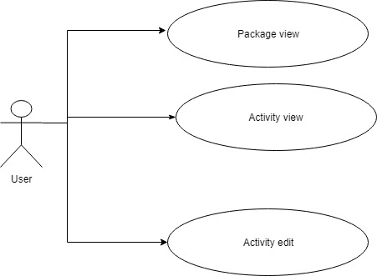

Figure 1: a use case for the user

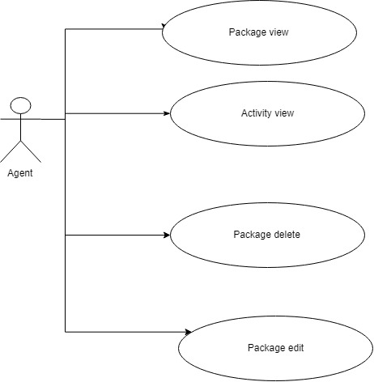

Figure 2: the functionality of agents on the system

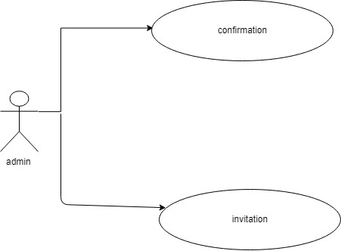

Figure 3: the functionality of admin on the system

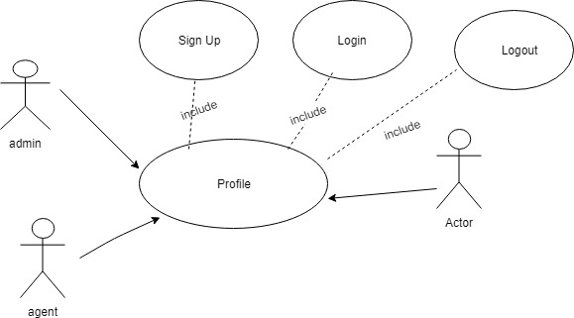

Figure 4: the functionality of login on the system for all the users

## 5.2 Sequence Diagram

A sequence diagram is an interaction diagram that depicts interaction between objects in a sequential order. The operations captures interaction between objects in the context of a collaboration. These diagrams are widely used by businessmen and software developers to understand requirements and document them for new and existing systems. It depicts the objects and classes which are involved in the system and the sequence of messages exchanged between the objects to carry out the functionality of the scenario. Sequence diagrams are typically associated with use case realizations in the Logical View of the system under development. Sequence diagrams are sometimes called event diagrams or event scenarios. These objects are shown in the order of interaction visually in vertical axis to represent message and functionality.

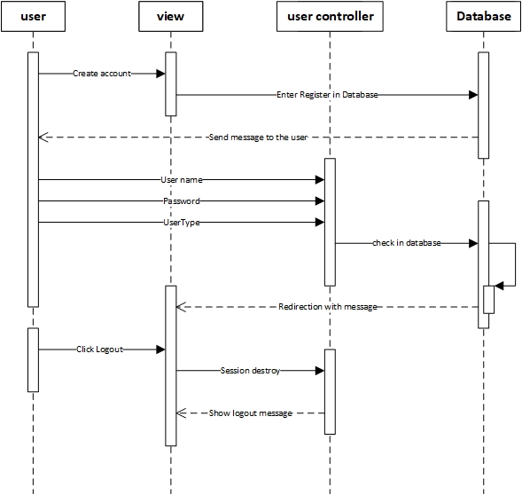

Fig 4: Login and logout sequence diagram

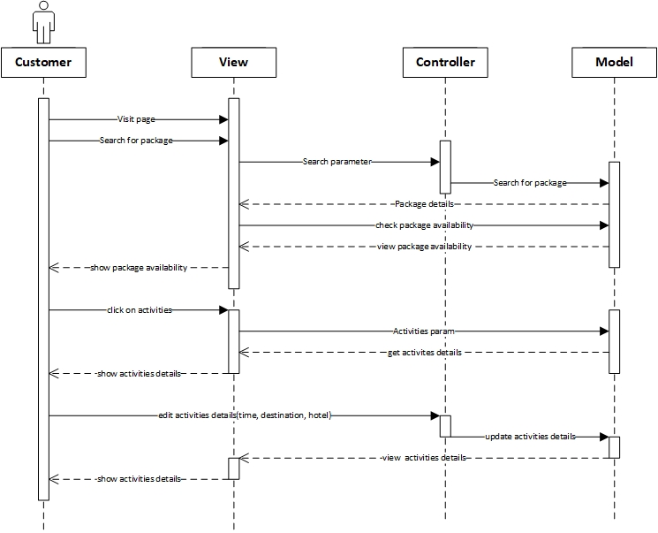

Fig 5: this figure determines the sequence of the features that traveler can access

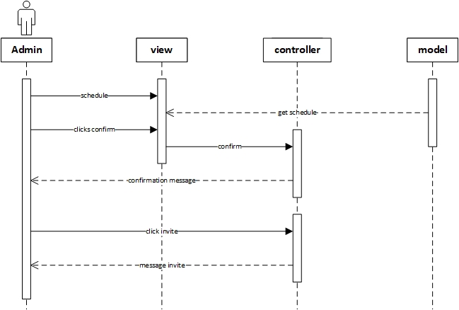

Fig 6: this figure determines the sequence of the features that admin can access

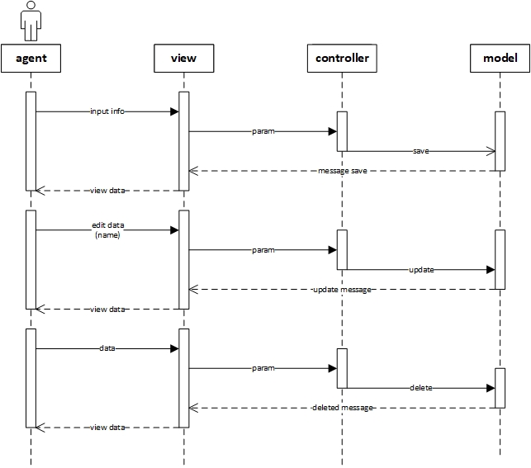

Fig 7: this figure determines the sequence of the features that agent can access

## 5.3 Class Diagram

In UML (Unified Modeling Language), a class diagram is a static representation of the structure of the system which describes by showing the classes, their attributes, functions and methods and relating them.

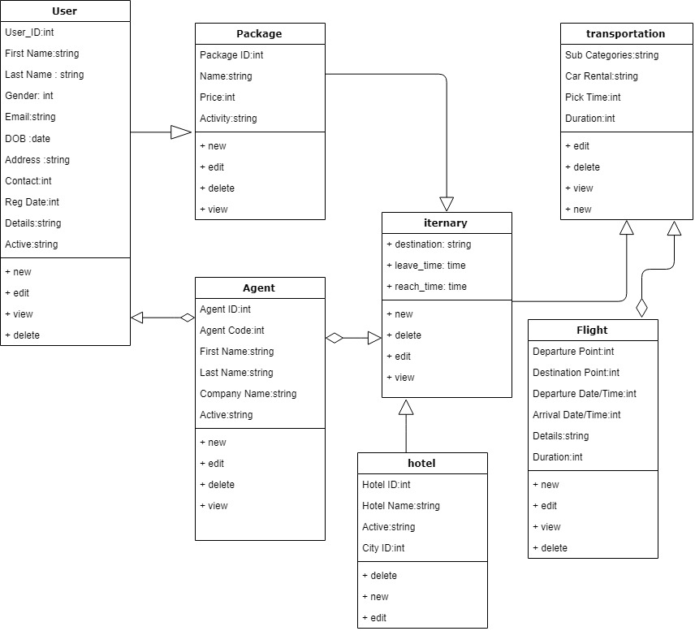

Fig 8: Class diagram of the personalized trip planner

In our diagram user is related to package and through those package the activities that occurs in the trip can be manipulated whereas the activities may concern hotels and transportations. Whereas also the agents/ travel agent are conjoined to user/traveler through these hereditary connections.

## 5.4 Activity Diagram

Similar to flowchart or the data flow diagram, Activity diagrams can be defined as visual representation of a series of action or workflow of controls in a system. Activities and actions that are modeled can be sequential and concurrent with the support of choice and iteration. In the unified modelling language UML, activity diagrams can be used to describe the business process modelling and operational series of workflows for components in a system. As activity diagram shows the overall flow of control it has initial state and a final state.

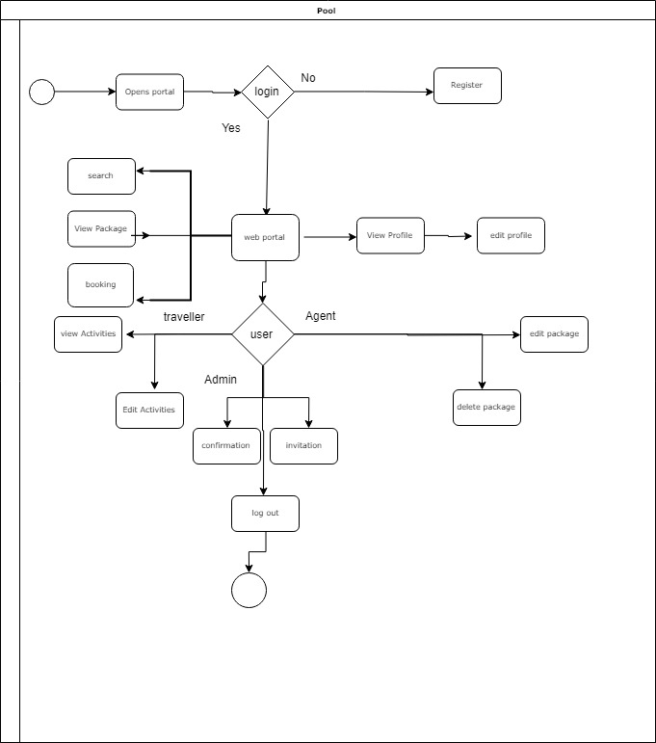

## 5.5 ER diagram

Entity relational data model can be defined as the data model where entities are linked with the help of link and described through relationship and attributes. So entity relationship diagram shows the relationship between entity sets that are stored in a database.

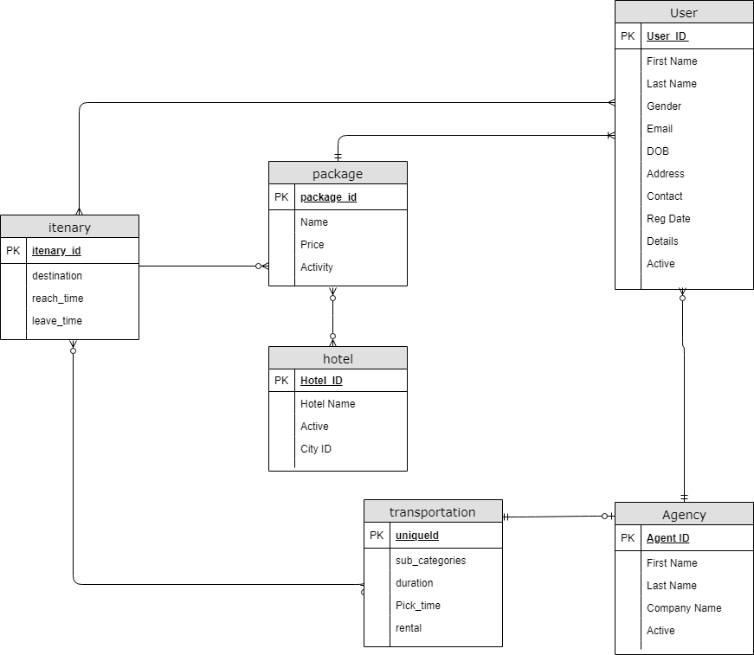

Fig 9: ER diagram of the personalized trip planner

# 6.0 Functional Requirements

## 6.1 Creation of a User

* Authenticate and Login user to the webapp.
* Enable new users to register to the tech support system.
* Enable a registered user to update his profile which includes his location, skills and profile picture.
* Enable a registered user to view his profile.

## 6.2 Major Functions

* Enable a user to view a travel package
* Enable a user to view an activity in the package
* Enable a logged in user to book the package.
* Enable a logged in user to edit the activities in the package.
* Enable a logged in user to search for the package.

## 6.3 Supporting the system

Enable the admin to confirm / send a message to the user about the package.

Enable the admin to invite / send a message to user to view the package.

## 6.4 Enhancing the system

• Provide an interface for the agent to edit the details of the packages. Such as;

The actual location of the package

The price presented in the package

• Provide an interface for the agent to edit the details within the activities of the package. Such as;

The number of days

Major destinations

# 7.0 Non-Functional Requirements

## 7.1 Design Standards

* **Performance**: System will be applicable to view the package and the activities in it. And also the activities can be edited. The software will support the use of multiple users at a time.
* **Usability**: As the website is purely a prototype we have tried to make it user friendly with least amount of effort to operate.
* **Portability**: The website is made using HTML, CSS, bootstrap, etc. which are platform independent, so the website can be transported to other servers with minimum effort and also used in most of the device.
* **Availability**: Instructor should be able to use the system anytime to access other information. This system must run on multiple operating systems and support windows / Other popular operating system.
* **Security**: We have only used the authorization technique for the system to be secured where user without right privileges cannot access/view any content.

## 7.2 Application Interface

Tools used to design the interface are

* Html
* CSS
* Jquery
* Bootstrap
* Rails
* Ruby
* Toastr / Sweetalert2

# 8 Future Direction

This is just a prototype interface for the trip planner in the future more functionality can be added to improve the efficiency. Initially, we have used all our group members as admin for major uses cases more users can be added and assigned with an interface.

Some of the future work of the Research for this Travels Management System that can be taken into consideration are listed down below:

* As the feature can be also increased the user interface can be more enhanced
* Increase Travel Agent tasks with multiple choices and types.
* Search function can be even more filtered with price ranges and others constraints
* This project is associated with a small location, so it can be enhanced to countries.
* We haven’t included payment in this project because the process of the payment is totally different with a separate server for payment. So, it can be included in the future works

# 9. Conclusion

With the growth of the internet, travel industry is rapidly changing and the demands of a whole new trend of idealistic-travel is a must. Travel agencies has been most active in the online travel business and is a dominant marketing channel in this industry. An agent is the irreplaceable part of the huge share of the market value covered by the travel booking sites. When a traveler thinks of a proper trip he/she plans the whole trip on advance .So our Trip planner is a platform to consider at first to plan and book these in advance.

Travelers today are realizing that despite the rise of OTAs, travel agents remain a strong option as far as personalized service is concerned, where a human being will listen to their needs and desires and can get a customized recommendation for travel that is beyond issuing tickets and vouchers. Therefore, travel agents must offer the highest service standards along with the convenience of online bookings to win the idealistic customers

When traveler starts his search for an outing in TP (Trip Planner), he will find several choices about price, availability, and modes of transportation and hotels, along with optional packages to make the excursion more exciting. In addition, the traveler will find information about the town that he will visit TP will make travel easier to plan an excursion, save cash and time for individual traveler. Also, it will help him to explore the hotels indifferently. In the end the system will provide many features that permit the user to book a flight, hotel or package. In addition, it finds sufficient information about places to visit, analyzes the cost and budget. Through the literature review, we found that some studies demonstrate the importance of planned travel to tourists and their impact while traveling and the presence of some applications that support the tourist while traveling. Also, there are some countries that support planned travel.

**Reference**

G. etal, (2006). *ONLINE TOURISM AND TRAVEL- ANALYSING TRENDS FROM MARKETING PERSPECTIVE*. [online] academia.edu. Available at: http://www.academia.edu//3466795/Online_Tourism-_Skyline.pdf [Accessed 21 May 2019].

Souﬀriau, W. and Vansteenwegen, P. (2010). *Tourist Trip Planning Functionalities: State–of–the–Art and Future*. [online] link.springer.com. Available at: https://link.springer.com/chapter/10.1007/978-3-642-16985-4_46 [Accessed 21 May 2019].

Soo, V. and Liang, S. (2001). *Recommending a Trip Plan by Negotiation with a Software Travel Agent*. [online] link.springer.com. Available at: https://link.springer.com/chapter/10.1007/3-540-44799-7_5 [Accessed 21 May 2019].